SPECIAL EDUCATION STAFF DEVELOPMENT FORM IN FRONTLINE
Staff will access Frontline to submit requests for Staff Development.
Go to the Staff Resource Page and choose 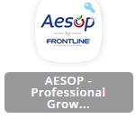
Then choose “Professional Growth” 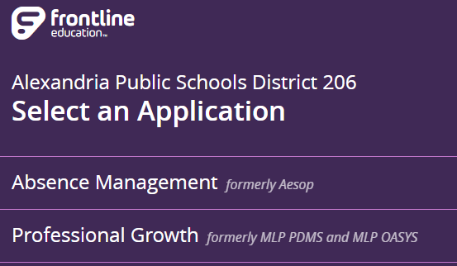
Your page will look like the picture below. 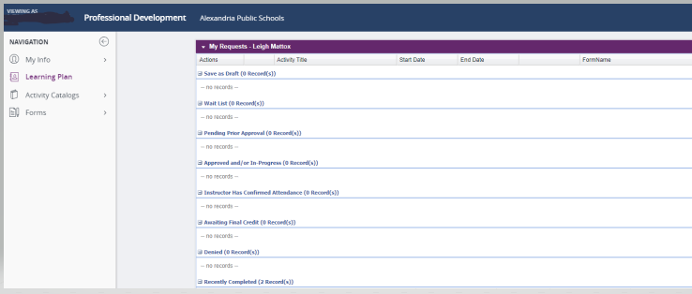
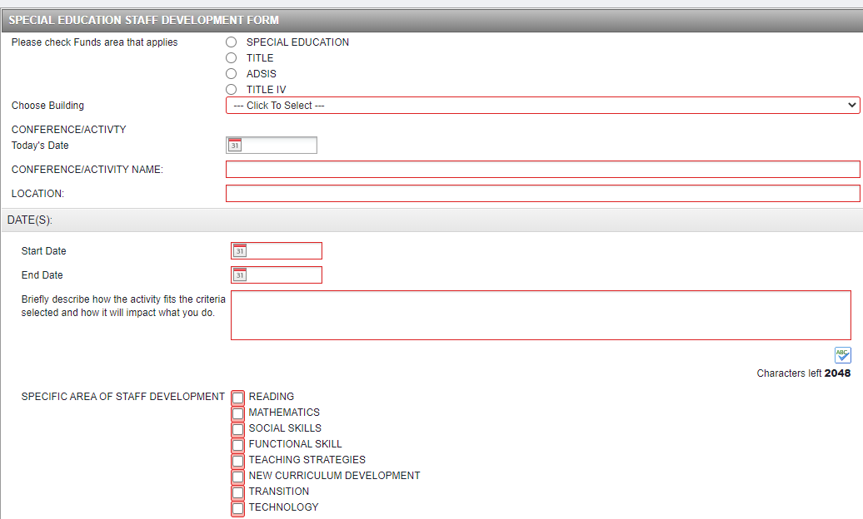
Choose “FORMS” on the left side of the screen, then choose “SPECIAL EDUCATION STAFF DEVELOPMENT”. Complete the form in its entirety and at the bottom select “SUBMIT”. The form will then be routed to the appropriate individual to be approved. You will receive an email notification whether it was approved/denied or requesting further information.

When you have completed the activity you will need to return to “Learning Plan” find the activity under “Approved and/or In-Progress” select “Manage” and then choose “Mark Complete”. The approver will then complete the Final Approval and you will see the activity in your “Learning Plan” under “Recently Completed” . You can choose “View My Portfolio” and view and or print any certificates

